**Problem 1:**

**SOURCE CODE:**

list = ['a','ab','abc','abcd', 'abcdef',''] # Input list

int_list = [] # Created empty list to store lenghts of words

def Find_length(a,b):

for i in a:

length = len(i)

b.append (length) # add length of each words in list

return (b) # return output

Find_length(list,int_list) # call function by passing required arguments

**OUTPUT:**

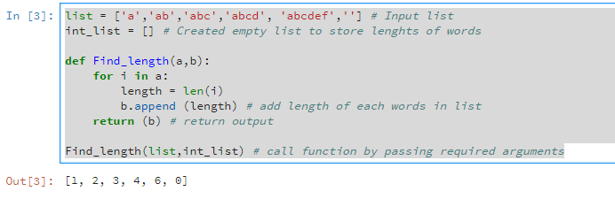

**Problem 2:**

**SOURCE CODE:**

vowels = ('a','e','i','o','u') # Store Vowels in a tuples

def Check(vowels): # Defining function and passing Vowels as argument

letter = input('Please enter the letter ') # Get letter

if len(letter)==1: # execute only if the input is one letter

print (letter in vowels) # check letter and print True or false

else:

print ('The input cannot be blank or more than 1 letter')

Check(vowels) # call function

**OUTPUT:**

